**DAILY ONLINE ACTIVITIES SUMMARY**

|  |  |  |  |  |  |  |  |
| --- | --- | --- | --- | --- | --- | --- | --- |
| **Date:** | **22/06/2020** | | | | **Name:** | **Imran Khan** | |
| **Sem & Sec** | **8th A** | | | | **USN:** | **4AL16CS040** | |
| **Online Test Summary** | | | | | | | |
| **Subject** | | **SMS** | | | | | |
| **Max. Marks** | | **--** | | **Score** | | **----** | |
| **Certification Course Summary** | | | | | | | |
| **Course** | **python** | | | | | | |
| **Certificate Provider** | | | **udemy** | **Duration** | | | **8 HOURS** |
| **Coding Challenges** | | | | | | | |
| Problem Statement:   C Program on largest palindrome. | | | | | | | |
| **Status: Solved** | | | | | | | |
| **Uploaded the report in Github** | | | | **yes** | | | |
| **If yes Repository name** | | | | **Imran040** | | | |
| **Uploaded the report in slack** | | | | **yes** | | | |

**Certification Course Details**:

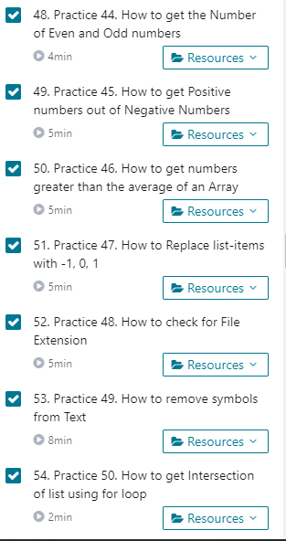

**Coding Challenges Details**:

**program1:**

|  |  |  |
| --- | --- | --- |
|  | | |
|  | | |
| #include<stdio.h> |
|  |  |
|  | int check_palindrome(int n) |
|  | { |
|  | int div = 1; |
|  | while (n / div >= 10) |
|  | div *= 10; |
|  |  |
|  | while (n != 0) |
|  | { |
|  | int first = n / div; |
|  | int last = n % 10; |
|  |  |
|  | // If first and last digits are not same then return false |
|  | if (first != last) |
|  | return -1; |
|  |  |
|  | // Removing the leading and trailing digits from the number |
|  | n = (n % div) / 10; |
|  |  |
|  | // Reducing divisor by a factor of 2 as 2 digits are dropped |
|  | div = div / 100; |
|  | } |
|  | return 1; |
|  | } |
|  | int large_palindrome(int A[], int n) |
|  | { |
|  | int i; |
|  | // Sort the array |
|  | for(int i=0; i<=n; i++) |
|  | { |
|  | for(int j=i; j<= n; j++) |
|  | { |
|  | if(A[i] >A [j]) |
|  | { |
|  | int temp = A[i]; |
|  | A[i] = A[j]; |
|  | A[j] = temp; |
|  | } |
|  | } |
|  | } |
|  |  |
|  | for(int i=0; i<n; i++) |
|  | { |
|  | printf("%d ", A[i]); |
|  | } |
|  |  |
|  | for (i=n-1; i >= 0; i--) |
|  | { |
|  | if (check_palindrome(A[i]) == 1) |
|  | return A[i]; |
|  | } |
|  | return -1; |
|  | } |
|  | int main() |
|  | { |
|  | int a[15], n, i; |
|  | printf("Enter the number of entries: \n"); |
|  | scanf("%d", &n); |
|  | printf("Enter the elements: \n"); |
|  | for(i=0; i<n; i++) |
|  | scanf("%d", &a[i]); |
|  | printf("\n Largest Palindrome: %d", large_palindrome(a, n)); |
|  | return 0; |
|  | } |